Static Testing and Dynamic testing

Static Testing
# Source: AI Source: Provided by: [Data Path: Persons Table -> ID Column: 1, Name_En Column: Motasem Essam] -> From: [ChatGPT] on [8/21/2025]
- Meaning: Testing without executing the code.
- Purpose: Find defects early by checking documents, design, and source code for errors.
- Where in the process: Happens early in the Software Development Life Cycle (SDLC) — before or during coding.
- Examples:
  - Reviewing requirement documents for clarity and completeness.
  - Code inspections or walkthroughs.
  - Using static analysis tools to catch syntax or style issues.
- Who does it: Developers, QA, or business analysts in review meetings.

Dynamic Testing
# Source: AI Source: Provided by: [Data Path: Persons Table -> ID Column: 1, Name_En Column: Motasem Essam] -> From: [ChatGPT] on [8/21/2025]
- Meaning: Testing by executing the code to check if it behaves as expected.
- Purpose: Verify the software’s functionality, performance, and behavior in real or simulated environments.
- Where in the process: Happens after the code is written and compiled — during test execution phases.
- Examples:
  - Unit testing
  - Integration testing
  - System testing
  - User acceptance testing (UAT)
- Who does it: Testers, QA engineers, sometimes end users.

Quick Comparison Table
# Source: AI Source: Provided by: [Data Path: Persons Table -> ID Column: 1, Name_En Column: Motasem Essam] -> From: [ChatGPT] on [8/21/2025]
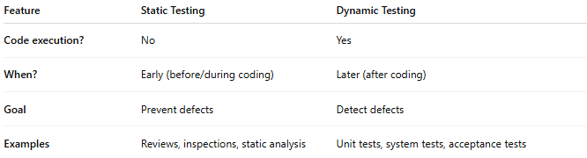
Feature | Static Testing | Dynamic Testing
Code execution? | No | Yes
When? | Early (before/during coding) | Later (after coding)
Goal | Prevent defects | Detect defects
Examples | Reviews, inspections, static analysis | Unit tests, system tests, acceptance tests

